**Pre-Requirements**

1. node
2. Visual Studio Code (VS-code) -

**Front-End**

1. Open Back-End directory in VS-code.
2. Run "npm i" command to install node_modules.

if above command didn't work for you then use "npm i --force" command.

1. use "npm run dev" to start project.

**Back-end**

1. Open Back-End directory in VS-code.
2. Run "npm i" command to install node_modules.

if above command didn't work for you then use "npm i --force" command.

1. use "npm run dev" to start project.

**Super Admin Front-end**

1. Open Back-End directory in VS-code.
2. Run "npm i" command to install node_modules.

if above command didn't work for you then use "npm i --force" command.

1. use "npm run dev" to start project.

**Super Admin Back-end**

1. Open Back-End directory in VS-code.
2. Run "npm i" command to install node_modules.

if above command didn't work for you then use "npm i --force" command.

1. use "npm run dev" to start project.

**Credentials**

* Organizer

**Email:** [gokulast14@gmail.com](mailto:gokulast14@gmail.com)

**Password:** *pAss123!@*

* Attendee

**Email:** [cs1812234@szabist.pk](mailto:cs1812234@szabist.pk)

**Password:** pAss123!@

or you can SignUp as Attendee.

**Sign-In**

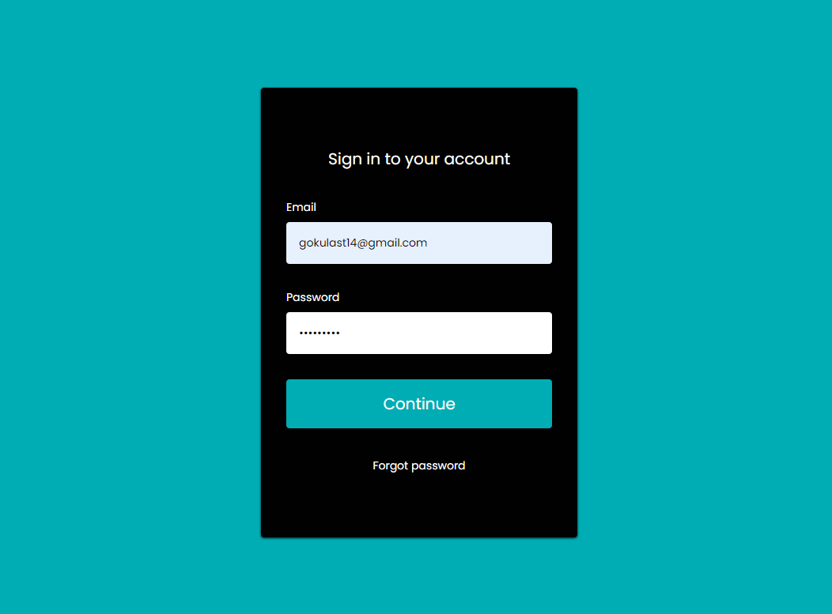

**Sign-Up**

1. **Email Authenticity Verification**

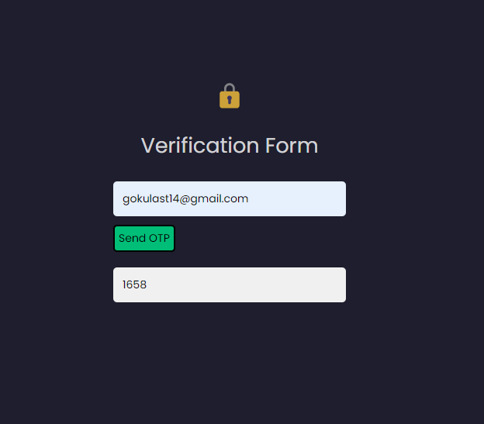

1. **Now You can Register**

